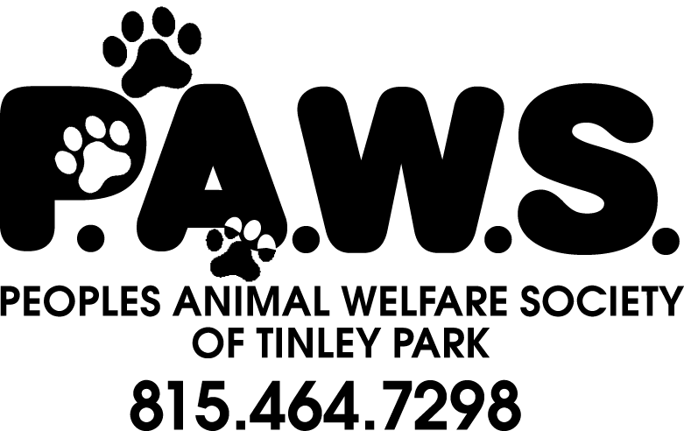
Paver Order Form

Remember or honor a favorite pet, pay tribute to your best friend/family member, or send a message to those who never had a loving place to call home. Your paver will be set into a place of honor in front of our shelter for all to admire.

**Please print clearly. Message centered or as printed below **

4” X 8” PAVER $75.00
(3 lines, 14 characters per line including spaces & punctuation)

8”X8” PAVER $125.00
(4 lines, 14 characters per line including spaces & punctuation)

Date of Submission: ______________________________________

Name: _______________________________________________________ Phone Number: ______________________________________

Address: ____________________________________________________ City, State, Zip: _______________________________________

Email Address: _______________________________________________________________________________________________________

We accept cash, checks, Visa, Master Card, or Discover. (Please circle)

Credit Card Number: __________________________________________________________ Expiration date: __________________

Pavers must be submitted in groups to be completed. Please allow at least 8 – 10 weeks for completion. You will be contacted when the pavers are placed at the shelter. For questions please contact pawstinleypark@gmail.com
Volunteers initials: ____________ Method of payment: Cash, Check, Credit Card.

